**Kathmandu University**

Department of Computer Science and Engineering

Dhulikhel, Kavre



Computer Graphics(COMP 342) – Lab 5

Submitted To:

Dhiraj Shrestha Sir

Department of Computer Science and Engineering

Submitted By:

Mission Shrestha (54)

CE-2019 Year/Sem: 3rd Year/2nd Sem

Submission Date: 26th May, 2023

**Implementation of Cohen Sutherland Line Clipping algorithm & Sutherland Hodgemann polygon clipping algorithm**

**1. CohenSutherland**

**Source Code:**

function cohenSutherland(P1, P2, Xw_min, Yw_min, Xw_max, Yw_max) {

  let x0 = P1[0];

  let y0 = P1[1];

  let x1 = P2[0];

  let y1 = P2[1];

  let vertexData = [];

  let P1_new = [...P1];

  let P2_new = [...P2];

  let m = (y1 - y0) / (x1 - x0);

  let regionCodeP1 = computeRegionCode(x0, y0, Xw_min, Yw_min, Xw_max, Yw_max);

  let regionCodeP2 = computeRegionCode(x1, y1, Xw_min, Yw_min, Xw_max, Yw_max);

  while (true) {

    if ((regionCodeP1 | regionCodeP2) === 0) {

      vertexData.push(...P1_new, ...P2_new);

      draw(gl, vertexData, "line");

      console.log(vertexData);

      vertexData = [];

      vertexData.push(...P1, ...P1_new, ...P2, ...P2_new);

      draw(

        gl,

        vertexData,

        "line",

        `void main(){ gl_FragColor = vec4(1, 0, 0, 1);}`

      );

      break;

    } else if ((regionCodeP1 & regionCodeP2) !== 0) {

      vertexData.push(...P1, ...P2);

      draw(

        gl,

        vertexData,

        "line",

        `void main(){ gl_FragColor = vec4(1, 0, 0, 1);}`

      );

      break;

    } else {

      let x, y;

      let regionCode = regionCodeP1 !== 0 ? regionCodeP1 : regionCodeP2;

      if ((regionCode & 1) !== 0) {

        x = Xw_min;

        y = y1 + m * (x - x1);

      } else if ((regionCode & 2) !== 0) {

        x = Xw_max;

        y = y1 + m * (x - x1);

      } else if ((regionCode & 4) !== 0) {

        y = Yw_min;

        x = x1 + (y - y1) / m;

      } else if ((regionCode & 8) !== 0) {

        y = Yw_max;

        x = x1 + (y - y1) / m;

      }

      if (regionCode === regionCodeP1) {

        regionCodeP1 = computeRegionCode(x, y, Xw_min, Yw_min, Xw_max, Yw_max);

        P1_new = [];

        P1_new = [x, y, 0];

      } else {

        regionCodeP2 = computeRegionCode(x, y, Xw_min, Yw_min, Xw_max, Yw_max);

        P2_new = [];

        P2_new = [x, y, 0];

      }

    }

  }

}

function computeRegionCode(x, y, Xw_min, Yw_min, Xw_max, Yw_max) {

  let code = 0;

  if (x < Xw_min) {

    code |= 1;

  } else if (x > Xw_max) {

    code |= 2;

  }

  if (y < Yw_min) {

    code |= 4;

  } else if (y > Yw_max) {

    code |= 8;

  }

  return code;

}

**2) Sutherland Hogdemann**

function sutherLandHodgemann(P1, P2, P3, P4, P5, Xw_min, Yw_min, Xw_max, Yw_max) {

  let vertexData = [];

  vertexData.push(

    ...P1,

    ...P2,

    ...P2,

    ...P3,

    ...P3,

    ...P4,

    ...P4,

    ...P5,

    ...P5

  );

  cohenSutherland(P1, P2, Xw_min, Yw_min, Xw_max, Yw_max);

  cohenSutherland(P2, P3, Xw_min, Yw_min, Xw_max, Yw_max);

  cohenSutherland(P3, P4, Xw_min, Yw_min, Xw_max, Yw_max);

  cohenSutherland(P4, P5, Xw_min, Yw_min, Xw_max, Yw_max);

  cohenSutherland(P5, P1, Xw_min, Yw_min, Xw_max, Yw_max);

}

**View Port:**function viewPortVertex(Xw_min, Yw_min, Xw_max, Yw_max) {

  const vertexData = [];

  let bottomLeft = [Xw_min, Yw_min, 0];

  let topLeft = [Xw_min, Yw_max, 0];

  let topRight = [Xw_max, Yw_max, 0];

  let bottomRight = [Xw_max, Yw_min, 0];

  vertexData.push(

    ...bottomLeft,

    ...topLeft,

    ...topLeft,

    ...topRight,

    ...topRight,

    ...bottomRight,

    ...bottomRight,

    ...bottomLeft

  );

  return vertexData;

}

**Output:**

**CohenSutherland:**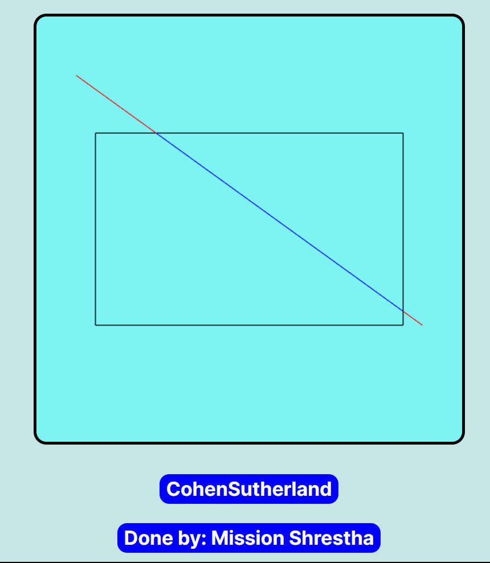

**SutherLandHodgeman**:  
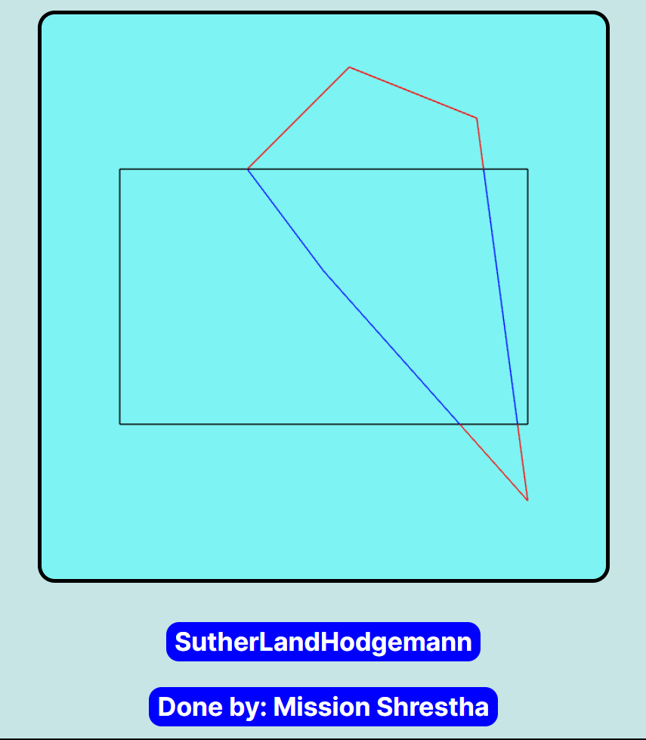

**Program Implementation of :**

**3D Translation**

**3D Rotation**

**3D Scaling**

**Source Code:  
  
Draw 3d:**let frontFace,

  backFace,

  leftFace,

  rightFace,

  topFace,

  bottomFace = [];

function DrawCube() {

  draw(backFace, 'triangle',`void main(){gl_FragColor = vec4(0, 0, 0, 1);}`);

  draw(leftFace, 'triangle',`void main(){gl_FragColor = vec4(1, 1, 1, 1);}`);

  draw(bottomFace, 'triangle',`void main(){gl_FragColor = vec4(1, 0, 1, 1);}`);

  draw(frontFace, 'triangle',`void main(){gl_FragColor = vec4(1, 0, 0, 1);}`);

  draw(rightFace, 'triangle',`void main(){gl_FragColor = vec4(0, 1, 0, 1);}`);

  draw(topFace, 'triangle', `void main(){gl_FragColor = vec4(0, 0, 1, 1);}`);

}

function draw3DObject(O, H, W, L) {

*// P2 P4*

*// P1 P3*

  let [x, y] = [O[0], O[1]];

  let P1 = [x, y, 1];

  let P2 = [x, y + H, 1];

  let P3 = [x + L, y, 1];

  let P4 = [x + L, y + H, 1];

  let P5 = createVertex(P3, W / 2, W / 2);

  let P6 = createVertex(P4, W / 2, W / 2);

  let P7 = createVertex(P2, W / 2, W / 2);

  frontFace = [...P1, ...P2, ...P3, ...P2, ...P3, ...P4];

  backFace = translateObject(frontFace, W / 1.75, W / 2.4);

  rightFace = [...P3, ...P4, ...P5, ...P4, ...P5, ...P6];

  leftFace = translateObject(rightFace, -L, 0);

  topFace = [...P2, ...P4, ...P7, ...P4, ...P6, ...P7];

  bottomFace = translateObject(topFace, 0, -H);

  DrawCube();

}

function createVertex(A, Tx, Ty) {

  let vertexData = [

    ...translateObject(

      rotateObject(

        -Math.PI / 20,

        translateObject(translateObject(A, Tx, Ty), -A[0], -A[1])

      ),

      A[0],

      A[1]

    ),

  ];

  return vertexData;

}

**Transformation:**function translate3DObject(Tx, Ty) {

  frontFace = translateObject(frontFace, Tx, Ty);

  backFace = translateObject(backFace, Tx, Ty);

  topFace = translateObject(topFace, Tx, Ty);

  bottomFace = translateObject(bottomFace, Tx, Ty);

  rightFace = translateObject(rightFace, Tx, Ty);

  leftFace = translateObject(leftFace, Tx, Ty);

  DrawCube();

}

function rotate3DObject(angle) {

  frontFace = rotateObject(angle, frontFace);

  backFace = rotateObject(angle, backFace);

  topFace = rotateObject(angle, topFace);

  bottomFace = rotateObject(angle, bottomFace);

  rightFace = rotateObject(angle, rightFace);

  leftFace = rotateObject(angle, leftFace);

  DrawCube();

}

function scale3DObject(Sx, Sy) {

  frontFace = scaleObject(frontFace, Sx, Sy);

  backFace = scaleObject(backFace, Sx, Sy);

  topFace = scaleObject(topFace, Sx, Sy);

  bottomFace = scaleObject(bottomFace, Sx, Sy);

  rightFace = scaleObject(rightFace, Sx, Sy);

  leftFace = scaleObject(leftFace, Sx, Sy);

  DrawCube();

}

**Tranform Object:**function translateObject(objectData, Tx, Ty) {

  let vertexData = [];

  let translationMatrix = [...[1, 0, Tx], ...[0, 1, Ty], ...[0, 0, 1]];

  vertexData.push(...matrixMultiplication(translationMatrix, objectData, 3));

  return vertexData;

}

function rotateObject(angle, objectData) {

  let vertexData = [];

  let cos = Math.cos(angle);

  let sin = Math.sin(angle);

  let rotationMatrix = [...[cos, -sin, 0], ...[sin, cos, 0], ...[0, 0, 1]];

  vertexData.push(...matrixMultiplication(rotationMatrix, objectData, 3));

  return vertexData;

}

function scaleObject(objectData, Sx, Sy) {

  let vertexData = [];

  let scalingMatrix = [...[Sx, 0, 0], ...[0, Sy, 0], ...[0, 0, 1]];

  vertexData.push(...matrixMultiplication(scalingMatrix, objectData, 3));

  return vertexData;

}

function matrixMultiplication(Transformer, coordinates, numElements) {

  let result = [];

  for (let i = 0; i < coordinates.length; i += 3) {

    for (let j = 0; j < 3; j++) {

      let sum = 0;

      for (let k = 0; k < numElements; k++) {

        sum += Transformer[j * 3 + k] * coordinates[i + k];

      }

      result.push(sum);

    }

  }

  return result;

}

**Output:**

**Original:  
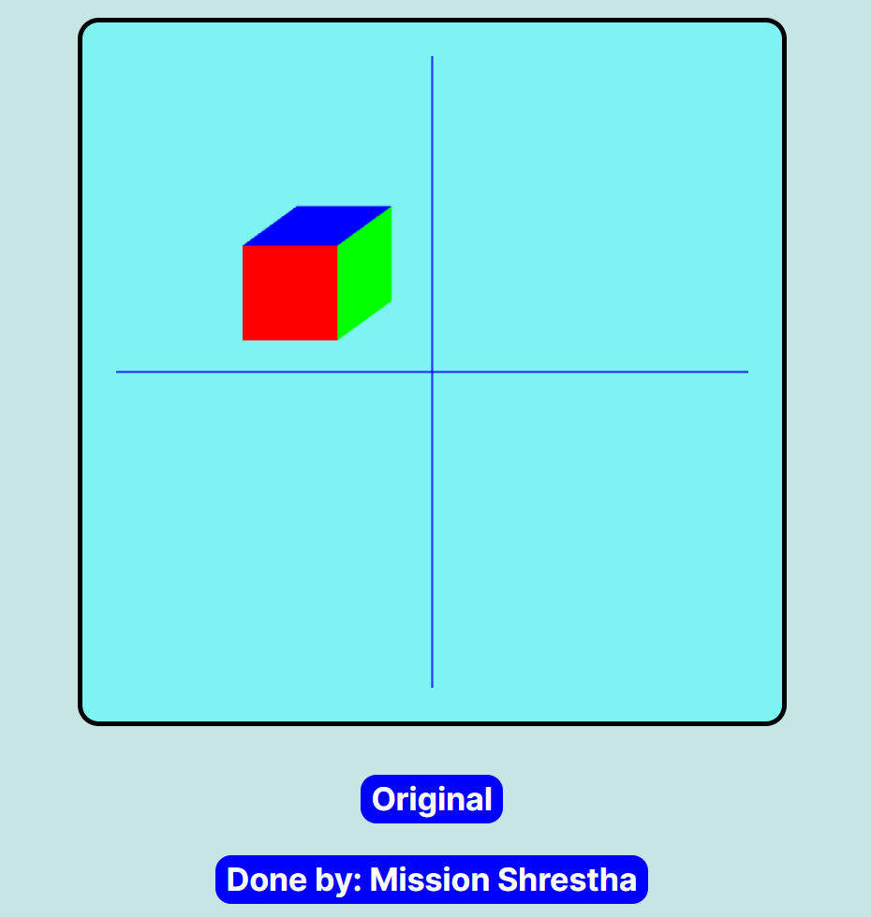**

**3D Translation:**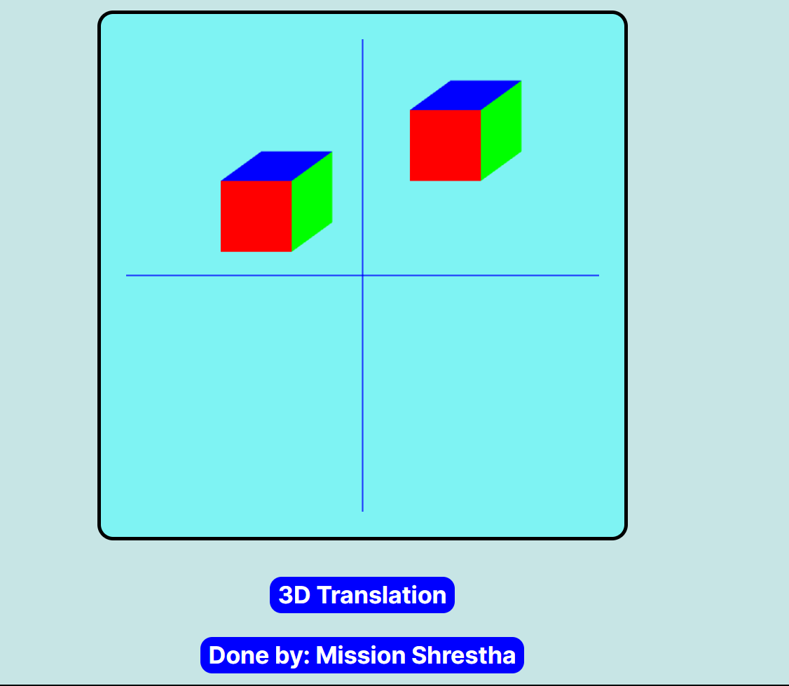

**3D Rotation**

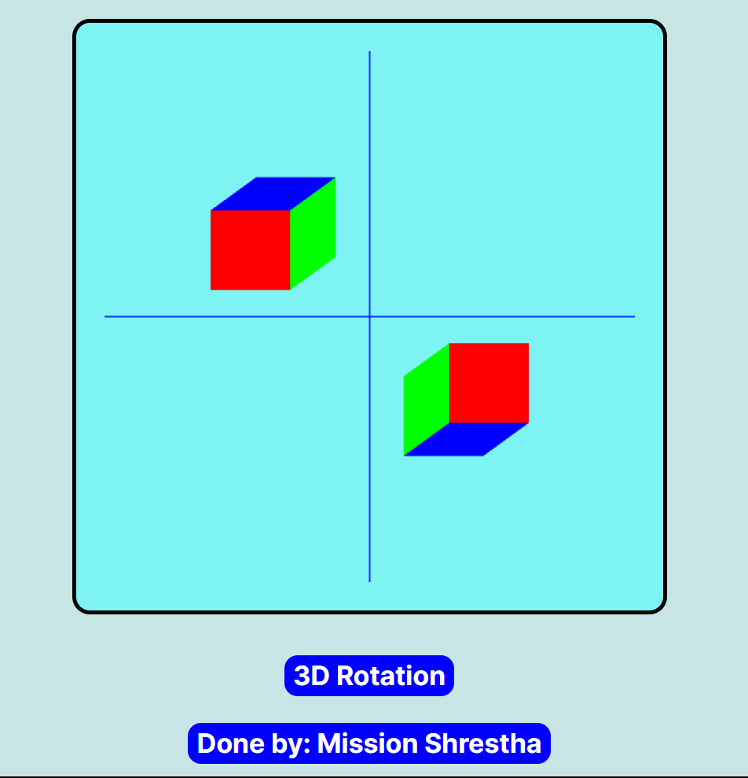

**3D Scaling:**

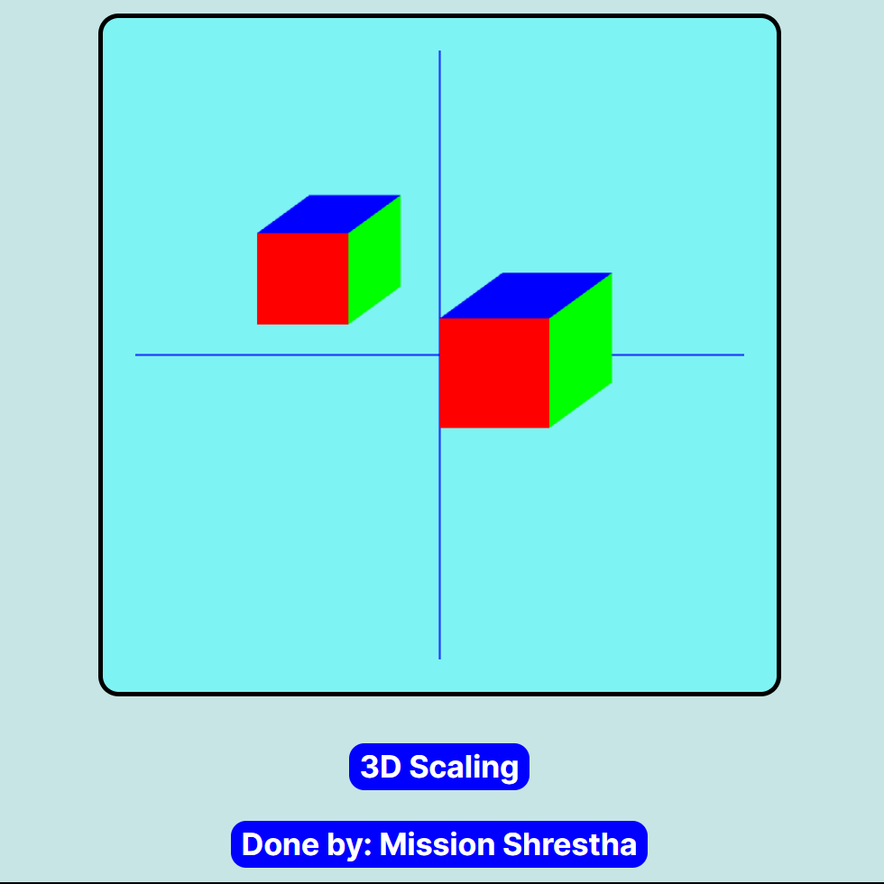

**Conclusion:**

In conclusion, LAB 5 involved the implementation of two popular clipping algorithms namely Cohen Sutherland Line Clipping algorithm and Sutherland Hodgemann polygon clipping algorithm. In addition, a program was developed to perform 3D translation, rotation, and scaling on any three-dimensional shapes.